**DAY 02**

**MARKETPLACE TECHNICAL FOUNDATION – COMFORTy**

**1. Technical Work:**

**Frontend Requirements**

* **User-Friendly: Easy navigation and intuitive product browsing.**
* **Responsive Design: Mobile, tablet, and desktop support.**
* **Essential Pages: Home, Product Listing, Product Details, Cart, Contact, About, FAQS, Checkout, Order Confirmation.**

**Sanity CMS as Backend**

* **Data Management: Manage products, customers, and orders.**
* **Schema Design: Create schemas for Products, Orders, and Customers.**
* **API Integration: Use Sanity APIs for frontend data fetching.**

**Third-Party APIs**

* **Shipment Tracking: Fetch delivery updates (e.g. ShipEngine, More).**
* **Payment Gateway: Secure payments (e.g., Snipcart, more).**
* **Notifications: Send order confirmations via email or SMS.**

**system arch:**

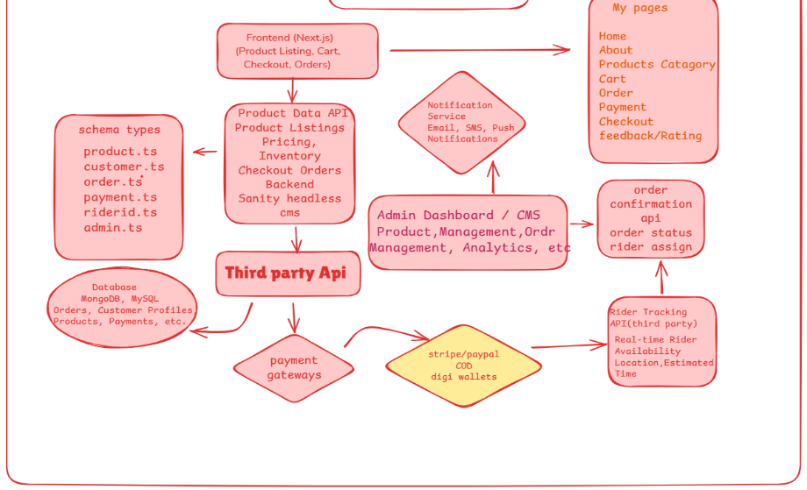

**3. API Requirements:**

**Product**

* **Endpoint Name: /products**
* **Method: GET**
* **Description: Fetch all available products from Sanity.**
* **Response: Product details (ID, name, price, description, stock, image).**

**Order**

* **Endpoint Name: /orders**
* **Method: POST**
* **Description: Create a new order in Sanity.**
* **Payload: Customer info, product details, payment status.**

**Customer**

* **Endpoint Name: /customers**
* **Method: POST**
* **Description: Register a new customer in the system.**
* **Payload: Customer info (name, email, address).**

**Delivery Zone**

* **Endpoint Name: /delivery-zones**
* **Method: GET (Third Party. e.g. ShipEngine, etc.)**
* **Description: Fetch available delivery zones.**
* **Response: Delivery zone details (ID, name, delivery cost).**

**Payment**

**Endpoint Name: /payment**

* **Method: POST (Third Party. e.g. Snipcart, etc.)**
* **Description: Process a payment for an order.**
* **Payload: Payment info (order ID, amount, payment method).**
* **Response: Payment status (successful or failed).**

**4. Documentation:**

* + **System Architecture Overview:**
  1. **Frontend (Next.js)**
* **Role: Displays the user interface, handles interactions, and provides server-side rendering for fast load times and SEO.**

1. **Backend (Sanity CMS)**

* **Role: Manages and stores dynamic content (products, orders, customer, delivery zone, payment) and provides APIs for the frontend to fetch data.**

1. **Third-Party APIs**

* **Role: Integrates external services for payment processing (Snipcart, more), shipping (shipengine, etc.), and other functionalities.**
* **Database (Managed by Sanity)**
* **Role: Stores structured data (products, users, orders) for easy access and management through Sanity’s APIs.**
  + **Key Workflows:**
  1. **Add to Cart**

1. **User adds products to cart (frontend updates state).**
   1. **Checkout**
2. **User enters shipping info, and shipping rates are fetched via ShipEngine.**
   1. **Payment**
3. **User makes payment via Snipcart API.**
   1. **Order Confirmation & Delivery**
4. **Order is confirmed, and shipping label is created via ShipEngine; user gets tracking details.**
   * **Workflow Diagram:**

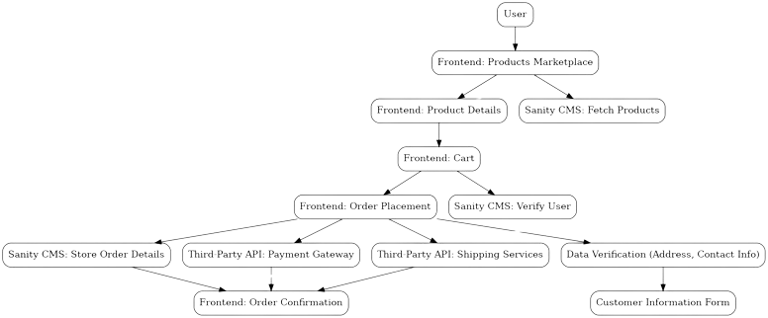

* + **Data Schema Design:**

**Entities and Relationships**

**Product**

1. **Fields:**
   1. **ID (number)**
   2. **Name (string)**
   3. **Price (number)**
   4. **Description (text)**
   5. **Image (image)**
   6. **Stock (number)**

**Order**

1. **Fields:**
   1. **ID**
   2. **Customer ID**
   3. **Quantity**
   4. **Total**
   5. **Order Status**

**Customer**

1. **Fields:**
   1. **Customer ID**
   2. **Name**
   3. **Email**
   4. **Phone**
   5. **Shipping Address**

**Delivery Zone**

1. **Fields:**
   1. **Zone ID**
   2. **Region**
   3. **Delivery Time, Charges**
   4. **Available Options**

**Payment**

1. **Fields:**
   1. **Payment ID**
   2. **Order ID**
   3. **Amount**
   4. **Payment Method**
   5. **Status**
   * **Technical Roadmap:**

**Phase 1: Planning**

1. **Define scope, features, wireframes.**
2. **Deliverables: Scope, UI mockups.**

**Phase 2: Frontend**

1. **Set up Next.js, cart, CMS integration.**
2. **Deliverables: Product catalog, cart.**

**Phase 3: Backend**

1. **Set up Sanity CMS, API routes, third-party integrations.**
2. **Deliverables: Backend, payment tracking.**

**Phase 4: Payment & Shipping**

1. **Integrate Snipcart, ShipEngine.**
2. **Deliverables: Payment, shipping setup.**

**Phase 5: Testing**

1. **Test and optimize.**
2. **Deliverables: Bug-free platform.**

**Phase 6: Deployment**

1. **Deploy site, set up monitoring.**
2. **Deliverables: Live site.**

**Phase 7: Post-Launch**

1. **Monitor and update.**
2. **Deliverables: Regular updates**.

**Name : Abdullah khan**

**Enrollment no : 40298**

**Slot : Saturday 9 to 12 pm**